List of Program

- Write a Java program to create a Banking application using package.
- Write a Java program to generate a Employee payroll using applet.
- Write a Java program to manipulate Strings using string methods.
- Write a Java program using Java methods.
- Write a Java program by implementing the concepts of Threads.
- Write a Java program to draw different shapes using Menus and Jframe.
- Write a Java program to catch various exceptions using Exception handling.
- Write a Java program to perform Client server chat.
- Write a Java program to copy the content from one file to the other.
- Write a Java program to add two numbers using AWT and applet.
- Write a Java program to generate electricity bill using Interface concepts.
- Write a Java progam to implement the utility concept using Calendar.

Pre Requisition
Knowledge to work with Net Beans IDE
Knowledge in Java core concepts

Guide to utilize the tool
- Open the NetBeans IDE
- Goto File and click on new Project to start with a new program
- Define the class name for the main function
- Declare the variables and code the concepts
- Save the program by clicking on the save menu.
- Click on the Run button to run the program

Java program to create a Banking application using package.
package test;
import java.io.*;
public class Bank
{
public String dname[]=new String[15];
public String acttype[]=new String[15];
public int acnum[]=new int[15];
public double amount[]=new double[15];
public int i=0;
public void newentry()throws IOException
{
DataInputStream in=new DataInputStream(System.in);
System.out.print("\n\t Enter the Depositer Name:");
dname[i]=in.readLine();
System.out.print("\n\t Enter the Account Type:");
acttype[i]=in.readLine();
System.out.print("\n\t Enter the Account Number:");
acnum[i]=Integer.parseInt(in.readLine());
System.out.print("\n\t Enter the Deposit Amount Rs:");
amount[i]=Double.parseDouble(in.readLine());
i=i+1;
}
public void deposit(double depositamt)throws IOException
{
DataInputStream in= new DataInputStream(System.in);
System.out.print("\n Enter the Account Number : ");
int accno1=Integer.parseInt(in.readLine());
for(int k=0;k<=i;k++)
{
if(acnum[k]==accno1)
{
double amt1=amount[k];
amount[k]=amt1+depositamt;
}
}
}
public void withdraw(double withdrawamt)throws IOException
{
DataInputStream in= new DataInputStream(System.in);
System.out.print("\n Enter the Account Number : ");
int accno=Integer.parseInt(in.readLine());
for(int k=0;k<=i;k++)
{
if(acnum[k]==accno)
{
if(amount[k]<withdrawamt)
{
System.out.println("\n You are not allowed to Withdraw...");
}
else
{
double amt=amount[k];
amount[k]=amt-withdrawamt;
}
}
}
}
public void show()
{
for(int j=0;j<i;j++)
{
System.out.println("\n\t Account Holder : "+dname[j]);
System.out.println("\n\t Account Number : "+acnum[j]);
System.out.println("\n\t Balance Amount Rs : "+amount[j]);
}
}
}

import test.*;
import java.io.*;
class Banking
{
public static void main(String args[])throws IOException
{
Bank a=new Bank();
int n;
do
{
DataInputStream in=new DataInputStream (System.in);
System.out.println("\n\n\t\t Banking ");
System.out.println("\n\n\t\t ---------------------- ");
System.out.println("\n 1. New Account Entry ");
System.out.println("\n 2. View Account");
System.out.println("\n 3. Deposit");
System.out.println("\n 4. Withdraw");
System.out.println("\n 5. Exit");
System.out.print("\n Enter Your Choice...");
n=Integer.parseInt(in.readLine());
switch(n)
{
case 1:
a.newentry();
break;
case 2:
a.show();
break;
case 3:
{
System.out.print("\n Enter the Deposit Amount Rs :");
a.deposit(Double.parseDouble(in.readLine()));
break;
}
case 4:
{
System.out.print("\n Enter the Withdraw Amount Rs :");
a.withdraw(Double.parseDouble(in.readLine()));
break;
}
case 5:
System.exit(0);
break;
}
}while(n!=5);
}
}

Java program to generate a Employee payroll using applet.
import java.awt.*;
import java.awt.event.*;
import java.applet.*;
//import java.applet.Applet;
/*<applet code="Emp.class" width=500 height=500></applet>*/
public class Emp extends Applet implements ActionListener
{
int x1=0,x2=0,x3=0,x4=0,x5=0,x6=0,x7=0;
String s1,s2,s3,s4,s5,s6,s7;
TextField t1,t2,t3,t4,t5,t6,t7;
Button b1,b2;
Label l1,l2,l3,l4,l5,l6,l7;
public void init()
{
l1=new Label("ENTER THE BASICPAY ",Label.LEFT);add(l1);
l2=new Label("HRA ",Label.LEFT);add(l2);
l3=new Label("DA ",Label.LEFT);add(l3);
l4=new Label("PF ",Label.LEFT);add(l4);
l5=new Label("IT ",Label.LEFT);add(l5);
l6=new Label("GROSSPAY ",Label.LEFT);add(l6);
l7=new Label("NETPAY ",Label.LEFT);add(l7);
t1=new TextField(10);add(t1);
t2=new TextField(10);add(t2);
t3=new TextField(10);add(t3);
t4=new TextField(10);add(t4);
t5=new TextField(10);add(t5);
t6=new TextField(10);add(t6);
t7=new TextField(10);add(t7);
b1=new Button("COMPUTE");add(b1);
b1.addActionListener(this);
b2=new Button("CLEAR");add(b2);
b2.addActionListener(this);
}
public void actionPerformed(ActionEvent e)
{
s1=t1.getText();
x1=Integer.parseInt(s1);
if(e.getSource()==b1)
{
x2=x1*8/100;
s2=String.valueOf(x2);
t2.setText(s2);
x3=x1*6/100;
s3=String.valueOf(x3);
t3.setText(s3);
x4=x1*4/100;
s4=String.valueOf(x4);
t4.setText(s4);
x5=x1*2/100;
s5=String.valueOf(x5);
t5.setText(s5);
x6=x1+x2+x3;
s6=String.valueOf(x6);
t6.setText(s6);
x7=x1+x2+x3-x5-x4;
s7=String.valueOf(x7);
t7.setText(s7);
}
if(e.getSource()==b2)
{
t1.setText("");
t2.setText("");
t3.setText("");
t4.setText("");
t5.setText("");
t6.setText("");
t7.setText("");
}
}
public void paint(Graphics g)
{
l1.setLocation(50,50);
l2.setLocation(50,80);
l3.setLocation(50,110);
l4.setLocation(50,140);
l5.setLocation(50,170);
l6.setLocation(50,200);
l7.setLocation(50,230);
t1.setLocation(230,50);
t2.setLocation(230,80);
t3.setLocation(230,110);
t4.setLocation(230,140);
t5.setLocation(230,170);
t6.setLocation(230,200);
t7.setLocation(230,230);
b1.setLocation(150,350);
b2.setLocation(250,350);
g.setFont(new Font("monotype corsiva",Font.BOLD,20));
g.drawString("EMPLOYEE DETAILS",80,20);
}
}
Java program to manipulate Strings using string methods.
import java.io.*;
class Stringmanipulation
{
public static void main(String args[])throws IOException
{
String s1,s2,x,y,x1,y1;
DataInputStream in=new DataInputStream(System.in);
System.out.println("\n Enter String 1");
s1=in.readLine();
System.out.println("\n Enter String 2");
s2=in.readLine();
if(s1.equals(s2))
{
System.out.println("\n Given strings are Equal");
}
else
{
System.out.println("\n Given strings are Not Equal");
}
System.out.println("\n Concatenated string is..."+s1.concat(s2));
System.out.println("\n Length of String");
System.out.println("\n ***********************");
System.out.println("\n The Length of string1 is..."+s1.length());
System.out.println("\n The Length of string2 is..."+s2.length());
System.out.println("\n Replace the String");
System.out.println("\n ***********************");
System.out.println("\n Replace String "+s1);
System.out.println("\n Enter the charcter to replace ");
x=in.readLine();
System.out.println("\n Enter the charcter to replace with");
y=in.readLine();
System.out.println("\n The Replaced String is "+s1.replace(x,y));
System.out.println("\n \nReplace String "+s2);
System.out.println("\n Enter the charcter to replace ");
x1=in.readLine();
System.out.println("\n Enter the charcter to replace with");
y1=in.readLine();
System.out.println("\n The Replaced String is "+s2.replace(x1,y1));
System.out.println("\n Lower Case to Upper Case");
System.out.println("\n ***********************");
System.out.println("\n Upper case of string 1 is "+s1.toUpperCase());
System.out.println("\n Upper case of string 2 is "+s2.toUpperCase());
System.out.println("\n Upper Case to Lower Case");
System.out.println("\n ***********************");
System.out.println("\n Upper case of string 1 is "+s1.toLowerCase());
System.out.println("\n Upper case of string 2 is "+s2.toLowerCase());
System.out.println("\n String Comparision");
System.out.println("\n ***********************");
int c=s1.compareTo(s2);
if(c==0)
{
System.out.println("\n Both Strings are Equal...");
}
if(c<0)
{
System.out.println(s1+"Lesser than"+s2);
}
if(c>0)
{
System.out.println(s1+"Greater than"+s2);
}
}
}

Java program using Java methods
class Methods {

// Constructor method

Methods() {
System.out.println("Constructor method is called when an object of it's class is created");
}

// Main method where program execution begins

public static void main(String[] args) {
staticMethod();
Methods object = new Methods();
object.nonStaticMethod();
}

// Static method

static void staticMethod() {
System.out.println("Static method can be called without creating object");
}

// Non static method

void nonStaticMethod() {
System.out.println("Non static method must be called by creating an object");
}
}

D:\Program Files\Java\jdk1.7.0_01\bin>javac Methods.java

D:\Program Files\Java\jdk1.7.0_01\bin>java Methods
Static method can be called without creating object
Constructor method is called when an object of it's class is created
Non static method must be called by creating an object

Java program by implementing the concepts of Threads.
import java.io.*;
class Six extends Thread
{
public void run()
{
System.out.println("Sixth Table");
for(int i=1;i<=5;i++)
{
System.out.println(" "+i+"*6 = "+i*6);
}
}
}
class Seven extends Thread
{
public void run()
{
try
{
System.out.println("Seventh Table");
for(int i=1;i<=5;i++)
{
System.out.println(" "+i+"*7 = "+i*7);
Thread.sleep(3000);
}
}
catch(InterruptedException e)
{
System.out.println("Exiting Seventh");
}
}
}
class Eight extends Thread
{
public void run()
{
System.out.println("Eighth Table");
for(int i=1;i<=5;i++)
{
System.out.println(" "+i+"*8 = "+i*8);
}
}
}
class Threadpgm
{
public static void main(String args[])
{
Six th_a=new Six();
Seven th_b=new Seven();
Eight th_c=new Eight();
th_a.start();
th_b.start();
th_c.start();
}
}

Java program to draw different shapes using Menus and Jframe
import java.io.*;
import javax.swing.*;
import java.awt.*;
import java.awt.event.*;
class Shape extends JFrame implements ActionListener
{
static int x=0,y=0,w=0,h=0;
JMenu shape,color;
JMenuItem rec,rrec,ovl,lin,refresh,green,blue;
Graphics graphics=null;
int s=0;
public Shape()
{
setTitle("Shapes");
JMenuBar mb=new JMenuBar();
shape=new JMenu("Shapes");
setJMenuBar(mb);

shape.setMnemonic('S');
rec=new JMenuItem("Rectangle");
rec.addActionListener(this);
shape.add(rec);
rrec=new JMenuItem("RoundRectangle");
rrec.addActionListener(this);
shape.add(rrec);

ovl=new JMenuItem("Oval");
ovl.addActionListener(this);
shape.add(ovl);
lin=new JMenuItem("Line");
lin.addActionListener(this);
shape.add(lin);
mb.add(shape);
color=new JMenu("Color");
color.setMnemonic('C');

green=new JMenuItem("Green");
color.add(green);
green.addActionListener(this);
blue=new JMenuItem("Blue");
color.add(blue);
blue.addActionListener(this);
refresh=new JMenuItem("Refresh");
refresh.addActionListener(this);
mb.add(color);
shape.add(refresh);
setDefaultCloseOperation(JFrame.EXIT_ON_CLOSE);
setBounds(x,y,w,h);
setVisible(true);
graphics=getContentPane().getGraphics();
}
public void actionPerformed(ActionEvent e)
{
if(e.getSource()==rec )
{
graphics.setColor(Color.RED);
graphics.fillRect(150,150,150,150);
s=1;
}
if(e.getSource()==rrec)
{
graphics.drawRoundRect(200,40,90,55,20,20);
s=2;
}
if(e.getSource()==ovl)
{
graphics.drawOval(290,100,90,55);
s=3;
}
if(e.getSource()==lin)
{
graphics.drawLine(250,30,90,30);
s=4;
}
if(e.getSource()==refresh)
{
graphics.clearRect(0,0,400,400);
}
if(e.getSource()==green)
{
graphics.setColor(Color.green);
if(s==1)
graphics.drawRect(150,150,150,150);
else if(s==2)
graphics.drawRoundRect(200,40,90,55,20,20);
else if(s==3)
graphics.drawOval(290,100,90,55);
else if(s==4)
graphics.drawLine(250,30,90,30);
}
if(e.getSource()==blue)
{
graphics.setColor(Color.blue);
if(s==1)
graphics.drawRect(150,150,150,150);
else if(s==2)
graphics.drawRoundRect(200,40,90,55,20,20);
else if(s==3)
graphics.drawOval(290,100,90,55);
else if(s==4)
graphics.drawLine(250,30,90,30);
}
}
public static void main(String args[])
{
x=Integer.parseInt(args[0]);

y=Integer.parseInt(args[1]);

w=Integer.parseInt(args[2]);

h=Integer.parseInt(args[3]);

new Shape();
}
}

Java program to catch various exceptions using Exception handling
class exp
{
public static void main(String args[])
{
int a=12,b=0,c;
System.out.println("Exception Program");
try
{
int i[]={2,6,10,14,4};
i[8]=i[2]-2;

}
catch(ArrayIndexOutOfBoundsException e)
{
System.out.println("Exception 1:"+e);
}
try
{
c=a/b;
}
catch(ArithmeticException e)
{
System.out.println("Exception 2: "+e);
}
System.out.println("After Exception");
}
}

Java program to perform Client server chat
import java.io.*;
import java.awt.*;
import java.net.*;
class Chatclient
{
public static void main(String args[])throws IOException
{
try
{
while(true)
{
Socket s=new Socket("localhost",3128);
InputStream in=s.getInputStream();
InputStreamReader in1=new InputStreamReader(in);
BufferedReader b=new BufferedReader(in1);
String x=b.readLine();
System.out.println("Message from Server : "+x);
System.out.println("------------------------------------------------");
if(x.equals("bye"))
break;
OutputStream out=s.getOutputStream();
PrintWriter pw=new PrintWriter(out,true);
BufferedReader br=new BufferedReader(new InputStreamReader(System.in));
System.out.print(" Type Your Message to Server : ");
String h=br.readLine();
if(h.equals("bye"))
break;
else
pw.println(h);
}
}
catch(IOException e)
{
System.out.println(e);
}
}
}

import java.io.*;
import java.awt.*;
import java.net.*;
class Chatserver
{
public static void main(String args[])throws IOException
{
int i;
try
{
ServerSocket ss=new ServerSocket(3128);
while(true)
{
Socket s=ss.accept();
OutputStream out=s.getOutputStream();
PrintWriter pw=new PrintWriter(out,true);
BufferedReader br=new BufferedReader(new InputStreamReader(System.in));
System.out.print(" Type Your Message to client : ");
String h=br.readLine();
if(h.equals("bye"))
break;
else
pw.println(h);
InputStream in=s.getInputStream();
InputStreamReader in1=new InputStreamReader(in);
BufferedReader b=new BufferedReader(in1);
String x=b.readLine();
System.out.println("Message from Client : "+x);
System.out.println("------------------------------------------------");
if(x.equals("bye"))
break;
}
}
catch(IOException e)
{
System.out.println(e);
}
}
}

Java program to copy the content from one file to the other.
import java.io.*;
class data
{
public static void main(String args[])throws IOException
{
BufferedReader d=new BufferedReader(new InputStreamReader(new FileInputStream("d:/java/java1.txt")));
DataOutputStream dis=new DataOutputStream(new FileOutputStream("d:/java/java2.txt"));
String line;
while((line=d.readLine())!=null)
{
String a=line.toUpperCase();
dis.writeBytes(a+"\r\n");
}
d.close();
dis.close();
}
}

COPYING FILE

D:\Program Files\Java\jdk1.5.0_05\bin>javac data.java
D:\Program Files\Java\jdk1.5.0_05\bin>java data

Java1.txt

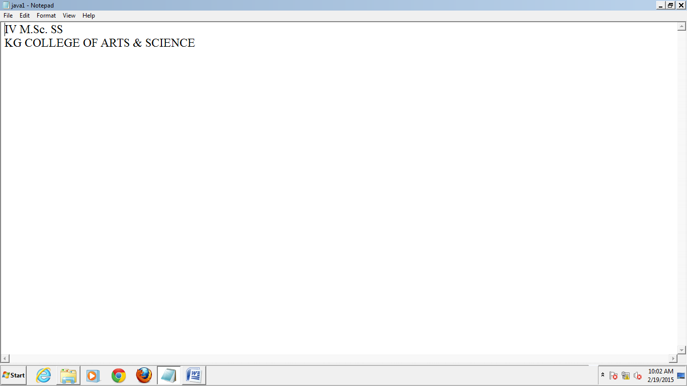

Java2.txt

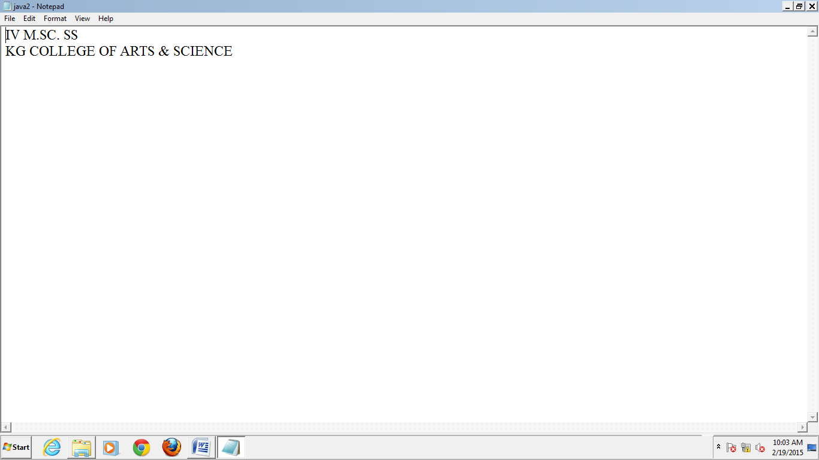
Java program to add two numbers using AWT and applet.
import java.applet.*;
import java.awt.*;
import java.awt.event.*;
public class textapplet extends Applet implements ActionListener
{
/*<applet code="textapplet" width=300 height=300></applet>*/
Button b;
TextField t1,t2,t3;
Label l1,l2,l3;
public void init()
{
setLayout(new FlowLayout(FlowLayout.LEFT));
l1=new Label("Enter the First Number");
t1=new TextField(5);
l2=new Label("Enter the Second Number");
t2=new TextField(5);
l3=new Label("The Sum is");
t3=new TextField(5);
b=new Button("Add");
add(l1);
add(t1);
add(l2);
add(t2);
add(l3);
add(t3);
add(b);
b.addActionListener(this);
}
public void actionPerformed(ActionEvent e)
{
int a=Integer.parseInt(t1.getText());
int b=Integer.parseInt(t2.getText());
t3.setText(a+b+"");
}
public void paint(Graphics g)
{
}
}

D:\Program Files\Java\jdk1.7.0_01\bin>javac textapplet.java
D:\Program Files\Java\jdk1.7.0_01\bin>appletviewer textapplet.java
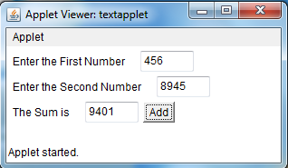
Java program to generate electricity bill using Interface concepts.
import java.io.*;
import java.lang.String;
class customer
{
int custno;
String name;
void getnumber(int no,String na)
{
custno=no;
name=na;
}
void putnumber()
{
System.out.println("\n\t\t Customer Number "+custno);
System.out.println("\n\t\t Customer Name "+name);
}
}
class reading extends customer
{
float pmr,cmr;
void getreading(float p,float c)
{
pmr=p;
cmr=c;
}
void putreading()
{
System.out.println("\n\t\t Previous Reading "+pmr);
System.out.println("\n\t\t Current Reading "+cmr);
}
}
interface units
{
float ut=0;
void putunit();
}
class result extends reading implements units
{
float nt;
double x;
public void putunit()
{
float ut=cmr-pmr;
System.out.println("\n\t\t Units="+ut);
}
void display()
{
float ut=cmr-pmr;
if(ut>=300)
x=ut*3.50;
else if(ut<300 && ut>=200)
x=ut*3.00;
else if(ut<200 && ut>=100)
x=ut*2.50;
else
x=ut*2.00;
putnumber();
putreading();
putunit();
System.out.println("\n\t\t Total Amount = "+x);
} }
class MulInherit
{
public static void main(String args[])throws IOException
{
DataInputStream x=new DataInputStream(System.in);
int cno;
String cna;
float cmr1,pmr1;
System.out.println("\n\t Enter the Customer Number ");
cno=Integer.parseInt(x.readLine());

System.out.println("\n\t Enter the Customer Name");
cna=x.readLine();
System.out.println("\n\t Enter the Previous Meter Reading ");
pmr1=Float.valueOf(x.readLine()).floatValue();
System.out.println("\n\t Enter the Current Meter Reading ");
cmr1=Float.valueOf(x.readLine()).floatValue();
result e=new result();
System.out.println("\n\t\t Electricity Bill");
System.out.println("\n\t-------------------------------");
e.getnumber(cno,cna);
e.getreading(pmr1,cmr1);
e.display();
System.out.println("\n\t-------------------------------");
}
}

Java progam to implement the utility concept using Calendar.
import java.util.Calendar;

public class Calendarexm {

public static void main(String[] args) {

//get instance of Calendar class
Calendar now = Calendar.getInstance();

/*
* Calendar class has several contstants which represents current date
* and time values
*/

//get current date, year and month
System.out.println("Current Year is : " + now.get(Calendar.YEAR));
//month start from 0 to 11
System.out.println("Current Month is : " + (now.get(Calendar.MONTH) + 1 ));
System.out.println("Current Date is : " + now.get(Calendar.DATE));

//get current time information
System.out.println("Current Hour in 12 hour format is : "
+ now.get(Calendar.HOUR));
System.out.println("Current Hour in 24 hour format is : "
+ now.get(Calendar.HOUR_OF_DAY));
System.out.println("Current Minute is : " + now.get(Calendar.MINUTE));
System.out.println("Current Second is : " + now.get(Calendar.SECOND));
System.out.println("Current Millisecond is : " + now.get(Calendar.MILLISECOND));

//display full date time
System.out.println("Current full date time is : " +
(now.get(Calendar.MONTH) + 1)
+ "-"
+ now.get(Calendar.DATE)
+ "-"
+ now.get(Calendar.YEAR)
+ " "
+ now.get(Calendar.HOUR_OF_DAY)
+ ":"
+ now.get(Calendar.MINUTE)
+ ":"
+ now.get(Calendar.SECOND)
+ "."
+ now.get(Calendar.MILLISECOND)
);
}
}

D:\Program Files\Java\jdk1.7.0_01\bin>javac Calendarexm.java

D:\Program Files\Java\jdk1.7.0_01\bin>java Calendarexm
Current Year is : 2016
Current Month is : 2
Current Date is : 26
Current Hour in 12 hour format is : 8
Current Hour in 24 hour format is : 8
Current Minute is : 42
Current Second is : 9
Current Millisecond is : 941
Current full date time is : 2-26-2016 8:42:9.941

